

Program: Post Graduate Diploma (PGD) in Data Science
Course Title: Data Science Project
Course: PGDDS 203
Project Title: Real-Life Project: NLP & Sentiment Analysis

Submitted by:
Student Name | ID
Md. Sahariar Sahen | 905253005

Submitted to:
Ahmed Imran Kabir,
Assistant Professor
School of Business & Economics (SoBE),
United International University (UIU)
Dhaka, Bangladesh

Table of Contents
1. Introduction 5
2. Dataset Description 5
3. Data Preprocessing 6
4. TF-IDF Feature Extraction 6
5. Train-Test Split 7
6. Model Selection and Implementation 7
7. Model Evaluation and Comparison 8
8. Classification Report 9
9. Confusion Matrix Analysis 10
10. Sentiment Trend Over Time 11
11. Sentiment Share by Source 12
12. Overall Interpretation of Results 13
13. Limitations 14
14. Improvement 14
15. Business Implications 14
16. Conclusion 14
17. Documentation and GitHub Presentation 15

List of Figures
Figure 1: Overall Sentiment Distribution 6
Figure 2: Model Comparison 8
Figure 3: Confusion Matrix — Logistic Regression 10
Figure 4: Sentiment Trend Over Time 11
Figure 5: Sentiment Share by Source 12

List of Tables
Table 1: Precision, Recall, F1-Score, and Support for Logistic Regression Classification 8

Introduction
The rapid growth of online platforms has resulted in a large volume of textual reviews and comments that reflect users' opinions and experiences with products. These textual data contain valuable information, but their unstructured nature makes it difficult to examine large numbers of reviews manually. Natural Language Processing (NLP) provides a systematic approach for processing such textual information, while machine-learning techniques can be used to automatically classify reviews according to their sentiment.
This project applies an NLP-based sentiment analysis approach to classify online reviews into three sentiment categories: Positive, Negative, and Neutral. The analysis is conducted using a synthetic dataset of 1,000 labeled reviews, containing information on review text, product, sentiment, source, date, and rating. The dataset represents reviews from different sources, allowing sentiment patterns to be examined not only at the overall level but also across sources and over time.
The analysis follows an end-to-end text-classification workflow. First, the review text is preprocessed to reduce unnecessary textual variation and prepare the data for analysis. The cleaned text is then transformed into numerical features using Term Frequency–Inverse Document Frequency (TF-IDF) with unigram and bigram features. The resulting feature representation is used to train three classification algorithms: Logistic Regression, Multinomial Naive Bayes, and Linear Support Vector Machine (SVM). The models are evaluated using accuracy, precision, recall, and F1-score, followed by a detailed examination of the classification results using a confusion matrix.
In addition to evaluating predictive performance, the project examines the distribution of sentiment within the dataset. Sentiment trends over time are analyzed to identify monthly changes in Positive, Negative, and Neutral reviews, while sentiment share by source is examined to identify differences among the sources represented in the dataset. These descriptive analyses provide additional context for interpreting the classification results.
The main objectives of this project are therefore to (i) preprocess and prepare textual review data for analysis, (ii) extract meaningful numerical features using TF-IDF, (iii) develop and compare three machine-learning models for three-class sentiment classification, (iv) evaluate model performance using multiple classification metrics and a confusion matrix, and (v) examine sentiment patterns across the available time period and review sources. Through these analyses, the project demonstrates a complete workflow for transforming unstructured review text into structured sentiment information and interpreting the resulting patterns.

Dataset Description
The analysis was conducted using the Excel dataset synthetic_online_reviews_sentiment_final.xlsx. The dataset contains 1,000 observations and seven variables: review_id, review_text, product, sentiment, source, date, and rating. Positive sentiment is the largest category, with 398 reviews, while neutral sentiment is the smallest, with 266 reviews. The three classes are all substantially represented in the dataset.

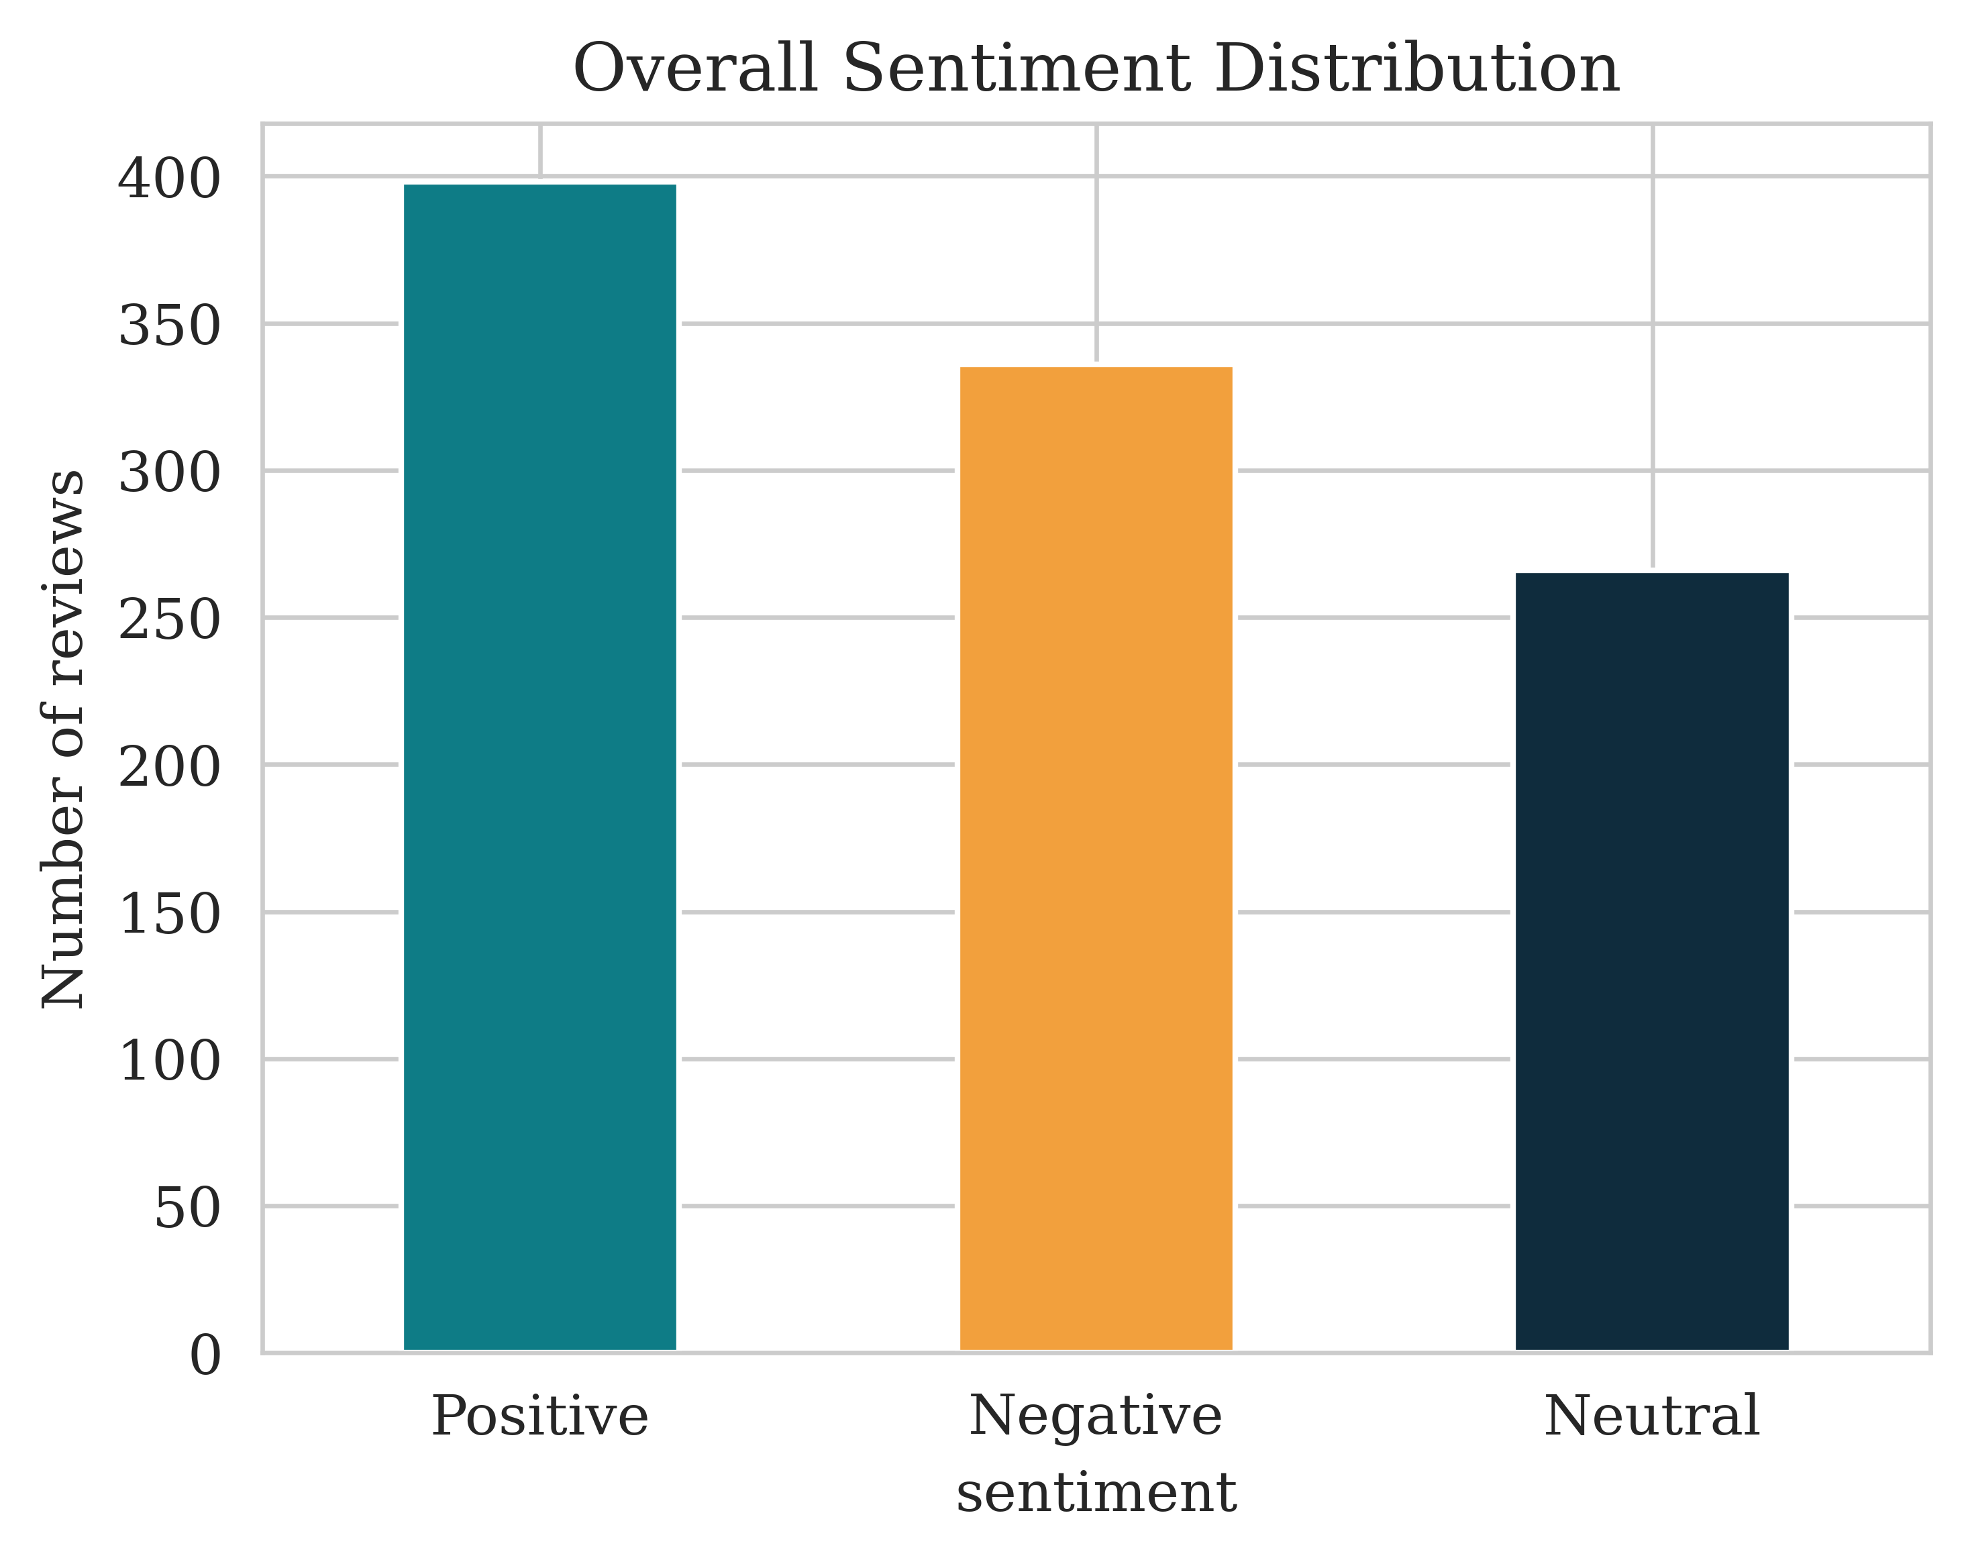
Figure 1: Overall Sentiment Distribution

Data Preprocessing
Before applying machine-learning classification models, the review text was preprocessed to reduce unnecessary textual variation and prepare the data for numerical feature extraction. The preprocessing pipeline was applied to the review_text field and included several sequential steps. First, all text was converted to lowercase so that words with different capitalization were treated consistently. URLs and user mentions were removed because they do not provide meaningful information for the sentiment classification task. Punctuation and other unnecessary textual symbols were also removed to simplify the text representation.
Following these cleaning steps, the review text was tokenized using NLTK's word_tokenize, which divided each review into individual words or tokens. English stopwords were then removed to reduce common words that contribute limited information to sentiment classification. The resulting processed text was stored in a new clean_text column. This cleaned representation was subsequently used as the input for TF-IDF feature extraction.

TF-IDF Feature Extraction
After completing the text preprocessing stage, the cleaned review text was transformed into numerical features using Term Frequency-Inverse Document Frequency (TF-IDF). This step converted the textual information into a numerical representation that could be used by the machine-learning classification models.
The TF-IDF vectorizer was configured with max_features=3000 and ngram_range=(1,2). The use of both unigrams and bigrams allowed the feature-extraction process to consider individual words as well as two-word combinations. This provided a representation of the review text based not only on individual terms but also on short word sequences. Although a maximum of 3,000 features was specified, the resulting TF-IDF representation contained 1,936 features across the 1,000 reviews. Therefore, the final TF-IDF matrix had a shape of (1000, 1936). This matrix served as the numerical input for the subsequent machine-learning classification models.

Train-Test Split
Following feature extraction, the dataset was divided into separate training and testing subsets to evaluate the performance of the classification models on unseen observations. An 80:20 train-test split was applied, resulting in 800 observations for training and 200 observations for testing. A stratified split was used based on the sentiment labels. This ensured that the three sentiment categories—Negative, Neutral, and Positive—remained represented in the training and testing datasets in proportions consistent with the original dataset. The split was performed using random_state=42, providing a fixed and reproducible division of the data.
The 800 training observations were used to train Logistic Regression, Multinomial Naive Bayes, and Linear SVM models, while the 200 testing observations were kept separate for evaluating their classification performance. This separation allowed the subsequent evaluation metrics to reflect how the trained models performed on data that was not used during model training.

Model Selection and Implementation
Following the text preprocessing and TF-IDF feature-extraction stages, three supervised machine-learning classification models were selected and trained to classify reviews into Negative, Neutral, and Positive sentiment categories: Logistic Regression, Multinomial Naive Bayes, and Linear Support Vector Machine (SVM). These models were selected because they provide three different classification approaches while being suitable for the TF-IDF representation generated from the review text.
Logistic Regression was included as a linear classification model for establishing a strong and interpretable baseline for the three-class sentiment classification problem. It uses the TF-IDF features to learn relationships between textual features and the sentiment classes.
Multinomial Naive Bayes was selected as a probabilistic classification approach. It provides a different modeling strategy from Logistic Regression by estimating the relationship between the observed text features and the possible sentiment categories. Its inclusion allows the performance of a probabilistic classifier to be compared with the linear models.
Linear SVM was selected as another linear classification approach. It determines decision boundaries between the sentiment categories based on the TF-IDF feature space. Including Linear SVM provides an additional comparison with Logistic Regression while using the same textual representation.
All three models were trained using the same TF-IDF feature matrix and the same stratified training dataset, while the held-out test set was kept unchanged for evaluation. This ensured that the models were compared under the same experimental conditions. The training set contained 800 observations, while 200 observations were reserved for testing.

Model Evaluation and Comparison

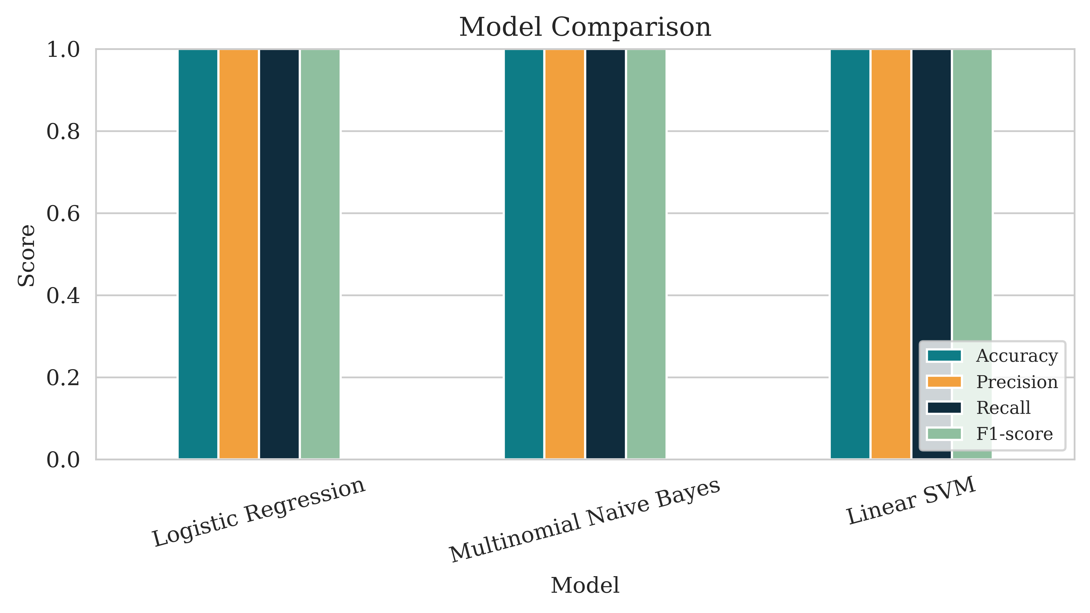
Figure 2: Model Comparison
The performance of the three sentiment classification models was evaluated using the same 200 observations in the test dataset. Logistic Regression, Multinomial Naive Bayes, and Linear SVM were assessed using four performance measures: accuracy, precision, recall, and F1-score. These metrics were selected to provide a comprehensive assessment of the classification performance rather than relying on accuracy alone.
As shown in Figure 2, all three classification models achieved identical performance across all four-evaluation metrics. Logistic Regression achieved an accuracy of 1.00, precision of 1.00, recall of 1.00, and F1-score of 1.00. Multinomial Naive Bayes produced exactly the same results, with all four metrics equal to 1.00. Linear SVM also achieved an accuracy, precision, recall, and F1-score of 1.00.
The accuracy of 1.00 indicates that all 200 observations in the test set were classified correctly by each of the three models. Similarly, the precision and recall values of 1.00 indicate that the models produced no observed incorrect positive predictions or missed observations within the test set. Since both precision and recall were perfect, the resulting F1-score was also 1.00 for all three models.
Therefore, the model comparison does not show any performance difference among Logistic Regression, Multinomial Naive Bayes, and Linear SVM based on the reported evaluation metrics. Although the analysis output identifies Logistic Regression as the "Best model," this designation does not represent a measurable performance advantage because all three models obtained exactly the same scores. Consequently, based strictly on the evaluation results, the three models performed equally on the test dataset.
The perfect results also indicate that the sentiment classes in the test observations were completely separated by all three classification approaches under the conditions of this experiment. However, this finding represents the performance obtained from the dataset and analysis used in this project and should be interpreted within that specific context.

Classification Report
Table 1: Precision, Recall, F1-Score, and Support for Logistic Regression Classification
Class | Precision | Recall | F1-score | Support
Negative | 1.00 | 1.00 | 1.00 | 67
Neutral | 1.00 | 1.00 | 1.00 | 53
Positive | 1.00 | 1.00 | 1.00 | 80
Accuracy |  |  | 1.00 | 200
Macro average | 1.00 | 1.00 | 1.00 | 200
Weighted average | 1.00 | 1.00 | 1.00 | 200

The classification report provides a more detailed examination of the Logistic Regression results by presenting precision, recall, F1-score, and support separately for each sentiment class.
The test dataset contained 67 Negative observations, 53 Neutral observations, and 80 Positive observations, giving a total test-set size of 200 observations. For the Negative class, Logistic Regression achieved a precision of 1.00, recall of 1.00, and F1-score of 1.00. The same results were obtained for the Neutral class, which contained 53 observations, and for the Positive class, which contained 80 observations.
This means that each of the three sentiment categories was classified correctly in the test set. There was no reduction in precision, recall, or F1-score for any particular class. The macro-average precision, recall, and F1-score were all 1.00, indicating identical performance when the three sentiment categories were considered equally. The weighted-average precision, recall, and F1-score were also 1.00, reflecting the fact that all 200 test observations were correctly classified.
The classification report therefore provides further evidence supporting the model-comparison results. In addition to achieving an overall accuracy of 1.00, Logistic Regression maintained the same perfect performance across Negative, Neutral, and Positive sentiment categories.

Confusion Matrix Analysis
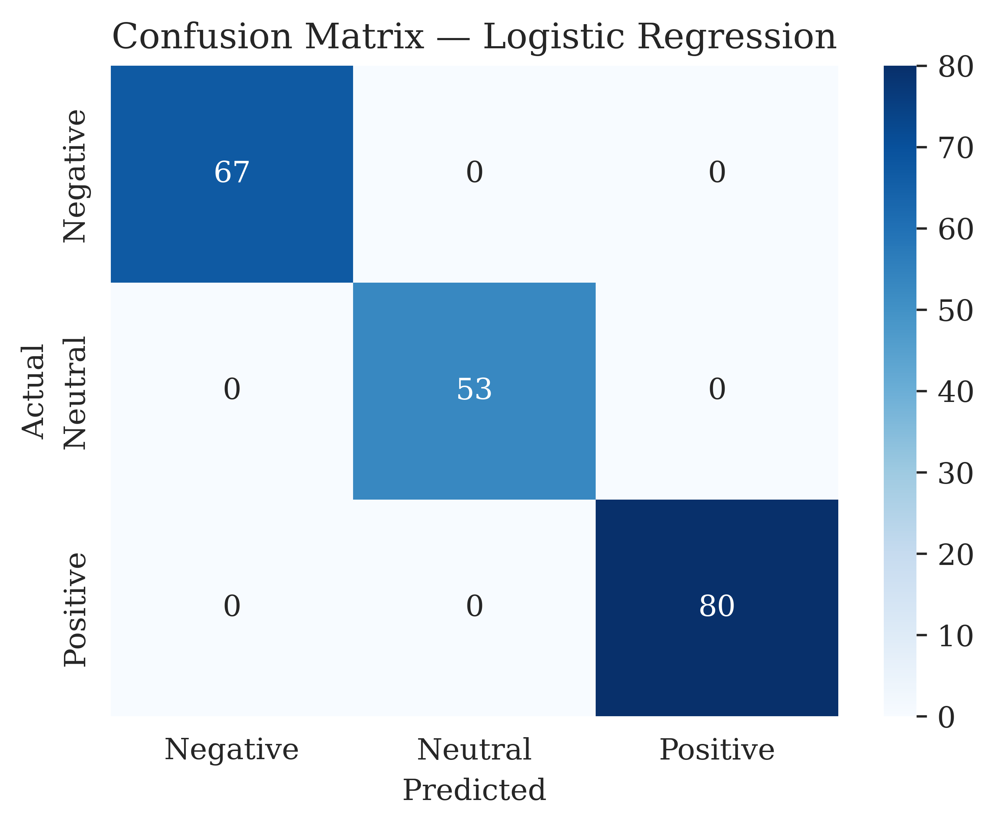
Figure 3: Confusion Matrix — Logistic Regression
The confusion matrix provides a detailed view of the relationship between the actual sentiment labels and the sentiment labels predicted by Logistic Regression. The matrix contains three sentiment categories: Negative, Neutral, and Positive.
The results show 67 observations in the Negative–Negative cell, indicating that all 67 actual Negative reviews were correctly predicted as Negative. Similarly, 53 observations appear in the Neutral–Neutral cell, meaning that all 53 actual Neutral reviews were correctly classified. The Positive–Positive cell contains 80 observations, showing that all 80 actual Positive reviews were correctly predicted as Positive.
Importantly, all off-diagonal cells contain a value of zero. This means that there were no cases in which a Negative review was predicted as Neutral or Positive, no Neutral review was predicted as Negative or Positive, and no Positive review was predicted as Negative or Neutral.
Therefore, the confusion matrix indicates zero observed classification errors in the 200-observation test set. No particular sentiment class was more frequently confused with another because there were no observed cases of confusion between the three classes.
The confusion matrix also directly supports the classification report and model-comparison results. The 67 correct Negative predictions, 53 correct Neutral predictions, and 80 correct Positive predictions account for all 200 test observations. Consequently, the matrix provides a direct explanation for the reported accuracy of 1.00.

Sentiment Trend Over Time
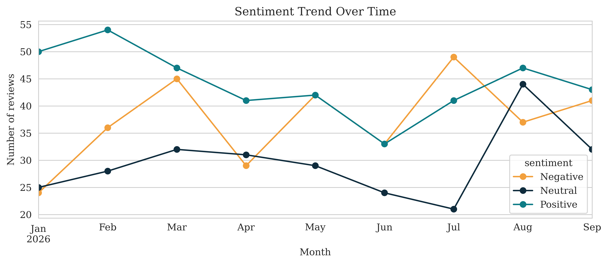
Figure 4: Sentiment Trend Over Time
The temporal analysis examines the number of Negative, Neutral, and Positive reviews from January to September 2026. The results show that the distribution of sentiment changes across the observation period, with different sentiment categories becoming more or less prominent in different months.
In January, Positive sentiment is clearly the most frequent category, with 50 reviews, compared with 24 Negative and 25 Neutral reviews. This indicates that Positive reviews represented the largest sentiment group at the beginning of the analyzed period.
In February, the number of Positive reviews increases further to 54, which is the highest monthly Positive count observed in the analysis. Negative sentiment increases to 36 reviews, while Neutral sentiment accounts for 28 reviews. Positive sentiment therefore remains substantially higher than the other two categories during February.
In March, the distribution becomes more balanced. Positive sentiment accounts for 47 reviews, while Negative sentiment reaches 45 reviews and Neutral sentiment reaches 32 reviews. The difference between Positive and Negative sentiment is therefore relatively small compared with the difference observed in January and February.
In April, Negative sentiment decreases to 29 reviews, while Positive sentiment remains higher at 41 reviews. Neutral sentiment accounts for 31 reviews. This month therefore shows a relatively stronger Positive pattern compared with Negative sentiment.
In May, Positive and Negative sentiment have exactly the same number of observations, with 42 reviews each. Neutral sentiment is lower at 29 reviews. This represents one of the months where the two main sentiment categories are evenly distributed.
In June, Negative and Positive sentiment are again equal, with 33 reviews each, while Neutral sentiment falls to 24 reviews. Compared with the previous months, all three categories show relatively lower counts.
A notable change occurs in July. Negative sentiment reaches its highest monthly count in the entire analysis, with 49 reviews. Positive sentiment accounts for 41 reviews, while Neutral sentiment falls to its lowest monthly count of 21 reviews. Consequently, July represents the month with the strongest observed Negative sentiment count.
In August, the pattern changes considerably. Neutral sentiment increases sharply to 44 reviews, representing the highest Neutral count observed during the analyzed period. Positive sentiment also remains high at 47 reviews, while Negative sentiment decreases to 37 reviews.
In September, the three sentiment categories become relatively close again. Positive sentiment accounts for 43 reviews, Negative sentiment for 41, and Neutral sentiment for 32.
Overall, the temporal analysis does not show a continuous increase or decrease in any single sentiment category. Instead, the results demonstrate month-to-month fluctuations. Positive sentiment reaches its highest count in February, Negative sentiment reaches its highest count in July, and Neutral sentiment reaches its highest count in August. The results therefore demonstrate that the sentiment composition of the analyzed reviews changes across the available observation period.

Sentiment Share by Source
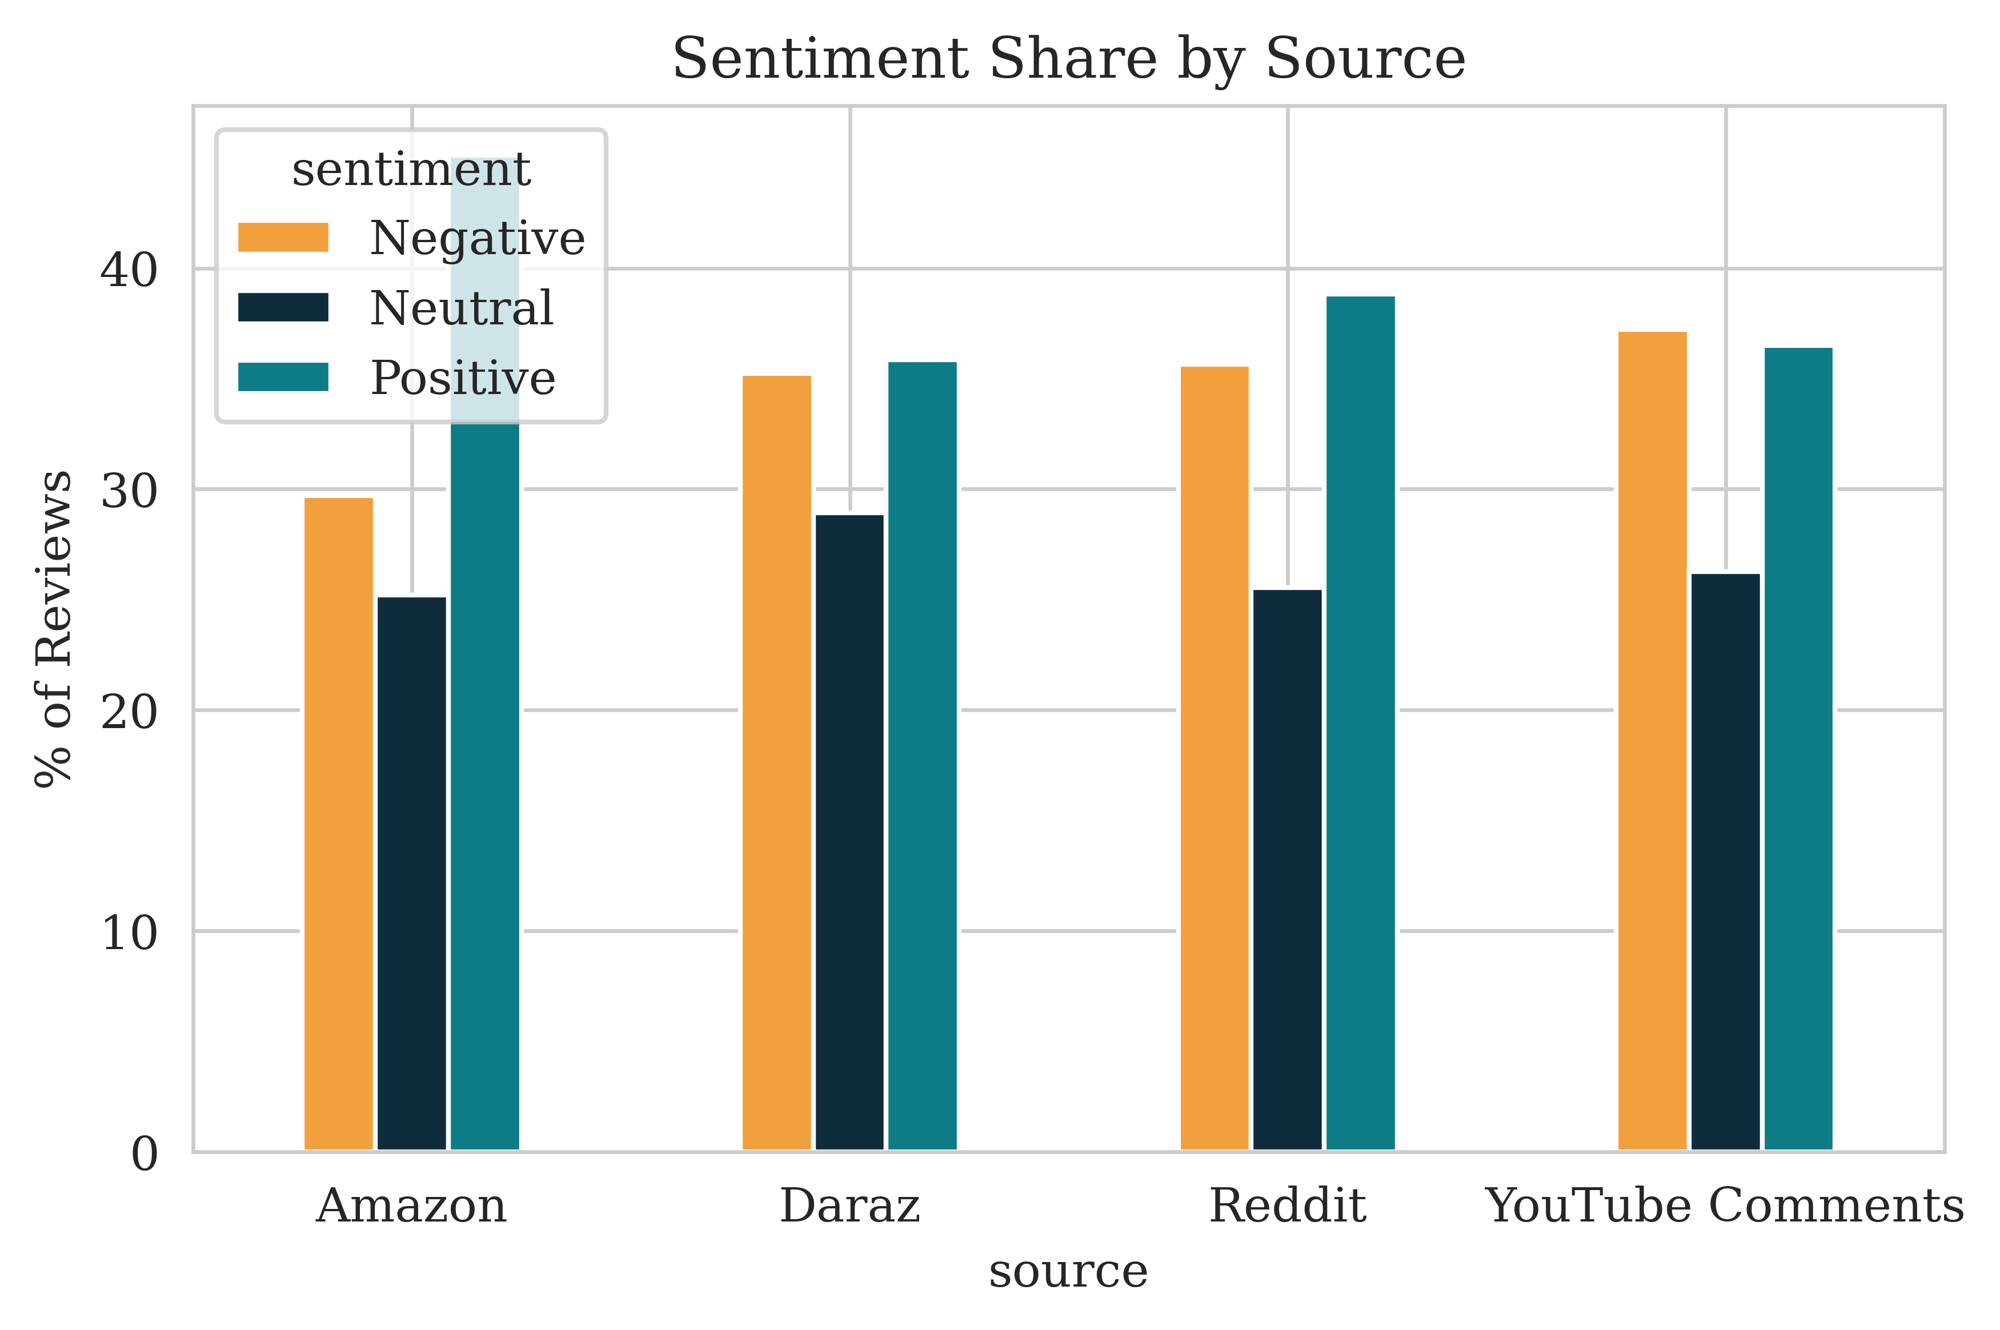
Figure 5: Sentiment Share by Source
The source-level analysis examines the proportion of Negative, Neutral, and Positive reviews across four sources: Amazon, Daraz, Reddit, and YouTube Comments. Unlike the temporal analysis, which examines changes across months, this analysis focuses on differences in sentiment composition between sources.
Amazon has the highest proportion of Positive reviews among the four sources, with Positive sentiment accounting for 45.1% of its reviews. Negative sentiment represents 29.7%, while Neutral sentiment accounts for 25.2%. Therefore, within the analyzed Amazon observations, Positive sentiment is clearly higher than both Negative and Neutral sentiment.
Daraz shows a considerably more balanced distribution between Positive and Negative sentiment. Positive reviews account for 35.8%, while Negative reviews account for 35.2%. The difference between the two categories is only 0.6 percentage points. Neutral sentiment represents 28.9% of the Daraz observations. Thus, among the four sources, Daraz has a particularly close balance between its Positive and Negative shares.
For Reddit, Positive sentiment represents 38.8% of the observations, while Negative sentiment accounts for 35.6%. Neutral sentiment represents 25.5%. Therefore, Positive sentiment is higher than Negative sentiment by 3.2 percentage points, while Neutral sentiment is the smallest of the three categories.
YouTube Comments presents a slightly different pattern. Negative sentiment represents 37.2% of the observations, which is the highest Negative share among the four sources. Positive sentiment accounts for 36.5%, while Neutral sentiment represents 26.3%. The difference between Negative and Positive sentiment is relatively small, at only 0.7 percentage points.
Overall, the source-level analysis demonstrates that the distribution of sentiment is not identical across the four sources. Amazon has the highest Positive sentiment share at 45.1%, while YouTube Comments has the highest Negative sentiment share at 37.2%. Daraz has the smallest difference between Positive and Negative sentiment, whereas Reddit shows a somewhat higher Positive share than Negative.
These findings complement the temporal analysis by providing another perspective on the distribution of sentiment in the dataset. The temporal analysis demonstrates how sentiment counts change over months, while the source analysis demonstrates how sentiment proportions differ according to the source of the review.

Overall Interpretation of Results
The findings from the classification and descriptive analyses provide two complementary perspectives on the dataset. The machine-learning analysis evaluates how effectively the review text can be classified into Negative, Neutral, and Positive categories, while the descriptive analysis examines how those categories are distributed across time and sources.
The classification results demonstrate that all three tested models—Logistic Regression, Multinomial Naive Bayes, and Linear SVM—achieved 1.00 accuracy, precision, recall, and F1-score on the 200-observation test set. The Logistic Regression confusion matrix further confirms that all 200 observations were correctly classified, with 67 Negative, 53 Neutral, and 80 Positive observations correctly assigned to their respective classes.
The descriptive analysis shows that Positive sentiment is the largest overall sentiment category in the dataset. However, the temporal analysis demonstrates that the distribution is not constant throughout the observation period. Positive sentiment is particularly prominent in January and February, Negative sentiment reaches its highest monthly count in July, and Neutral sentiment reaches its highest monthly count in August.
The source-level analysis similarly demonstrates variation among the four sources. Amazon has the highest Positive sentiment share, while YouTube Comments has the highest Negative sentiment share. Daraz shows an almost equal distribution between Positive and Negative sentiment, while Reddit has a moderately higher Positive share than Negative.
Taken together, these findings show that the project successfully combines sentiment classification with descriptive sentiment analysis. The classification models provide the automated prediction component, while the temporal and source-level analyses provide a clearer understanding of how sentiment is distributed within the analyzed dataset.

Limitations
First, the dataset is synthetic, so the patterns observed in this project represent the provided dataset. Second, the temporal analysis covers January through September 2026 only. Third, TF-IDF represents text using word and two-word features and therefore the analysis is based on the selected textual representation. Finally, all three models achieved perfect test performance, so the current experiment does not provide a performance difference with which to distinguish the models.

Improvement
A concrete improvement would be to repeat the same analysis on a larger and more varied review dataset. This would allow the same preprocessing, TF-IDF representation, and three classification models to be evaluated under more varied textual conditions. Extending the observation period would also allow a longer temporal analysis.

Business Implications
The analysis demonstrates how a company can use sentiment information to monitor customer feedback. The overall sentiment distribution provides a general picture of positive, negative, and neutral opinions, while the temporal analysis identifies changes across months and the source analysis identifies differences among Amazon, Daraz, Reddit, and YouTube Comments. A similar automated classification system could be used to classify new textual reviews and organize customer feedback into sentiment categories.

Conclusion
This project developed an end-to-end NLP-based sentiment analysis pipeline using 1,000 synthetic online reviews. The workflow included text preprocessing, TF-IDF feature extraction, an 80:20 stratified train-test split, and three classification algorithms: Logistic Regression, Multinomial Naive Bayes, and Linear SVM.
All three models achieved 1.00 accuracy, precision, recall, and F1-score on the 200-observation test set. The Logistic Regression confusion matrix showed that all 67 Negative, 53 Neutral, and 80 Positive test observations were correctly classified, with zero misclassifications.
The descriptive analysis showed that Positive sentiment was the largest overall category, sentiment varied across the available months, and sentiment shares differed across sources. Overall, the analysis successfully demonstrates a complete workflow for sentiment classification and interpretation using the submitted dataset and analysis.

Documentation and GitHub Presentation
The project was implemented and documented in Google Colab, with the notebook containing the complete workflow from data preprocessing and TF-IDF feature extraction to model training, evaluation, and visualization. The code and outputs are organized sequentially for easy understanding and reproducibility.
GitHub Repository:

